**SQL PROJECT 2**

**AIR CARGO ANALYSIS**

**1. Write a query to create route_details table using suitable data types for the fields, such as route_id, flight_num, origin_airport, destination_airport, aircraft_id, and distance_miles. Implement the check constraint for the flight number and unique constraint for the route_id fields. Also, make sure that the distance miles field is greater than 0.**

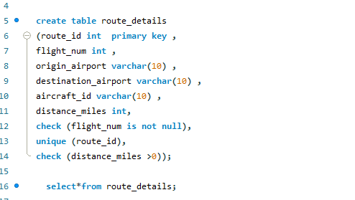

**2.Write a query to display all the passengers (customers) who have travelled in routes 01 to 25. Take data  from the passengers_on_flights table.**

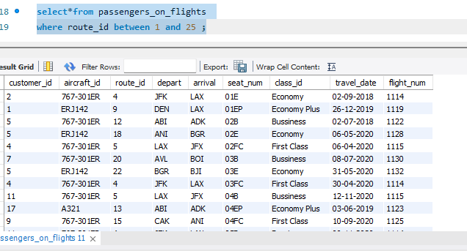

**3.Write a query to identify the number of passengers and total revenue in business class from the ticket_details table.**

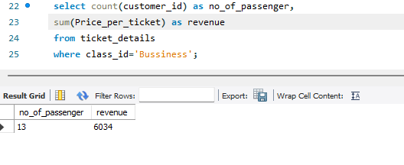

**4. Write a query to display the full name of the customer by extracting the first name and last name from the customer table.**

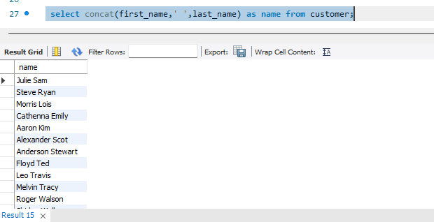

**5.Write a query to extract the customers who have registered and booked a ticket. Use data from the customer and ticket_details tables.**

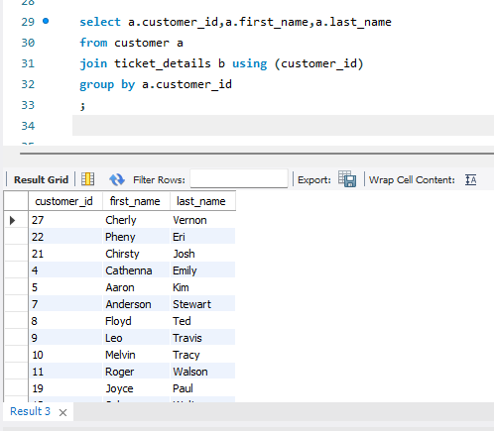

**6. Write a query to identify the customer’s first name and last name based on their customer ID and brand (Emirates) from the ticket_details table**

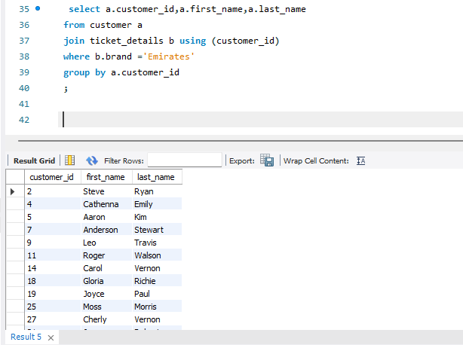

**7. Write a query to identify the customers who have travelled by *Economy Plus* class using Group By and Having clause on the passengers_on_flights table.**

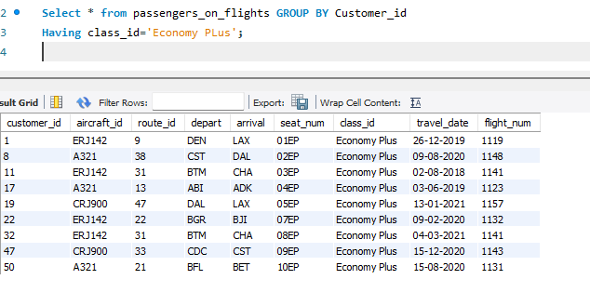

**8. Write a query to identify whether the revenue has crossed 10000 using the IF clause on the ticket_details table.**

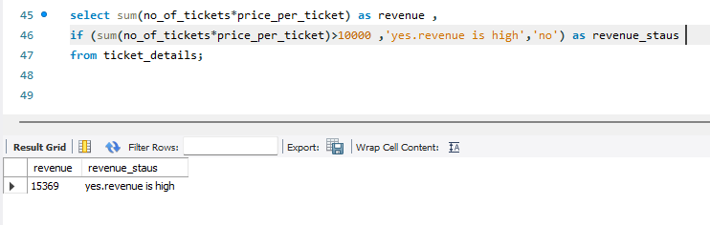

**9. Write a query to find the maximum ticket price for each class using window functions on the ticket_details table.**

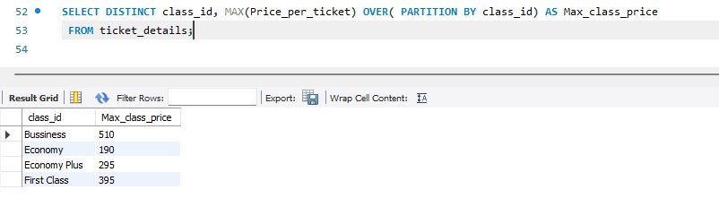

**10. Write a query to extract the passengers whose route ID is 4 by improving the speed and performance of the passengers_on_flights table.**

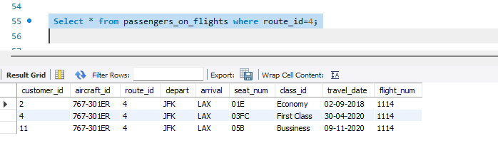

**11. Write a query to calculate the total price of all tickets booked by a customer across different aircraft IDs using rollup function.**

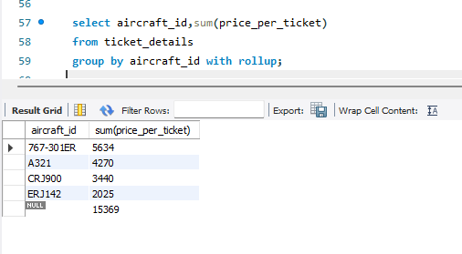

**12. Write a query to create a view with only business class customers along with the brand of airlines.**

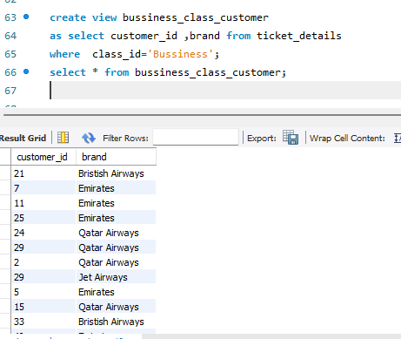

**13. Write a query to create a stored procedure to get the details of all passengers flying between a range of routes defined in run time. Also, return an error message if the table doesn't exist.**

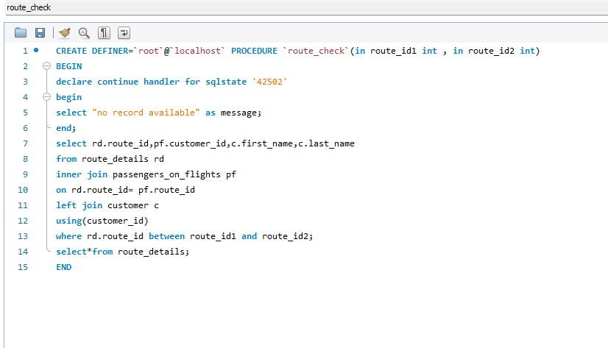

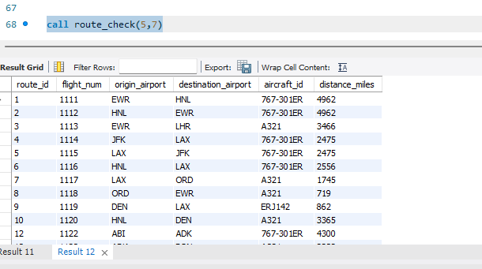

**14. Write a query to create a stored procedure that extracts all the details from the routes table where the travelled distance is more than 2000 miles.**

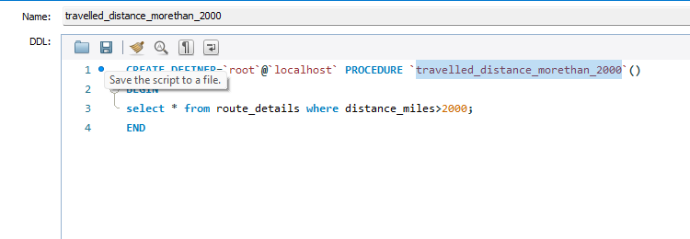

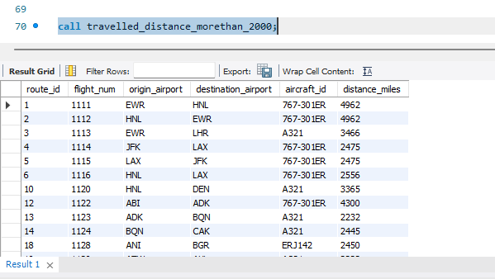

**15. Write a query to create a stored procedure that groups the distance travelled by each flight into three categories. The categories are, short distance travel (SDT) for >=0 AND <= 2000 miles, intermediate distance travel (IDT) for >2000 AND <=6500, and long-distance travel (LDT) for >6500.**

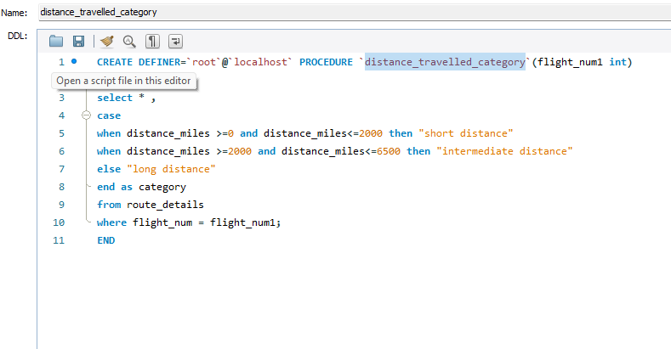

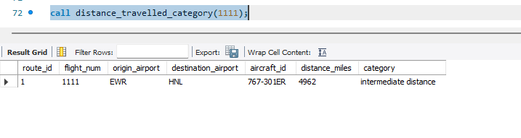

**16. Write a query to extract ticket purchase date, customer ID, class ID and specify if the complimentary services are provided for the specific class using a stored function in stored procedure on the ticket_details table.**

**Condition:**

* **If the class is *Business* and *Economy Plus,* then complimentary services are given as *Yes,*else it is *No***

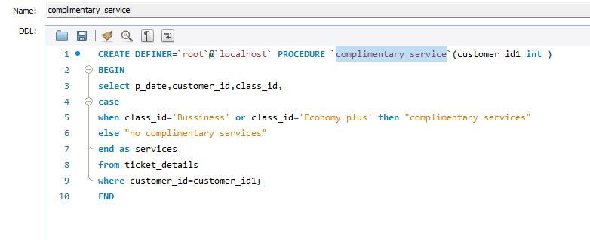

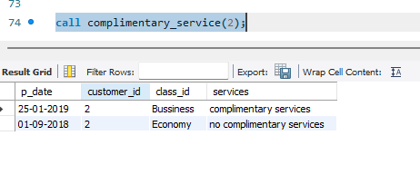

**17. Write a query to extract the first record of the customer whose last name ends with Scott using a cursor from the customer table.**



